LAB EXPERIMENT 5

AIM
To design and develop an Online Flight Reservation System using HTML, CSS, and JavaScript to search flights, book tickets, manage reservations, and view booking details through a user-friendly web interface.

PROCEDURE
- Create a project folder named Online Flight Reservation System.
- Create an HTML file named index.html to design the structure of the website.
- Use HTML to create the required sections, such as flight search, passenger details, ticket booking, payment, and booking history.
- Use CSS to style the website and make it user-friendly and responsive.
- Use JavaScript to implement flight searching, seat selection, ticket booking, payment simulation, ticket cancellation, and booking status checking.
- Add sample flight details, including departure, destination, travel date, flight number, and ticket fare.
- Open the index.html file in a web browser such as Google Chrome or Microsoft Edge.
- Enter the departure and destination details, select the travel date and class, and search for available flights.
- Select a flight, enter passenger details, and complete the simulated payment process.
- Display the booking confirmation and ticket details. Use the print option to print or save the ticket as a PDF.
- Test the website to verify that the flight search, booking, cancellation, and booking status features work correctly.

Save the following complete code as index.html.
<!DOCTYPE html>
<html lang="en">
<head>
<meta charset="UTF-8">
<meta name="viewport" content="width=device-width,initial-scale=1.0">
<title>Online Flight Reservation System</title>
<style>
body{font-family:Arial;margin:0;background:#f1f4f8;color:#202938}
header{background:#123c69;color:white;text-align:center;padding:15px}
.container{max-width:800px;margin:20px auto;padding:20px;background:white;border-radius:10px;box-shadow:0 3px 10px #0002}
h2{color:#123c69}
label{display:block;margin-top:10px;font-weight:bold}
input,select{width:100%;box-sizing:border-box;padding:9px;margin-top:5px}
button{padding:10px 14px;margin-top:12px;background:#123c69;color:white;border:0;border-radius:5px;cursor:pointer}
.cancel{background:#b3261e}
.card{margin-top:12px;padding:12px;background:#eaf3ff;border-radius:7px;overflow-wrap:anywhere}
.note{font-size:13px;color:#555}
footer{text-align:center;padding:12px}
@media print{header,footer,button,hr,.container>h2,.container>label,.container>input,.container>select,.container>ul,.note,#flightResults,#bookingMessage,#statusResult,#cancelMessage{display:none!important}body{background:white}}
</style>
</head>
<body>
<header><h1>Online Flight Reservation System</h1><p>Search Flights | Book Tickets | Check PNR</p></header>
<div class="container">
<h2>1. Search Flights</h2>
<label>Departure City</label><input id="departure" placeholder="e.g. Chennai">
<label>Destination City</label><input id="destination" placeholder="e.g. Delhi">
<label>Travel Date</label><input id="travelDate" type="date">
<label>Travel Class</label>
<select id="travelClass"><option>Economy</option><option>Business</option><option>First Class</option></select>
<button onclick="searchFlights()">Search Flights</button><div id="flightResults"></div>
<hr>
<h2>2. Book a Ticket</h2>
<label>Passenger Name</label><input id="passengerName" placeholder="Enter full name">
<label>Passenger Age</label><input id="passengerAge" type="number" min="1" max="120" placeholder="Enter age">
<label>Email Address</label><input id="passengerEmail" type="email" placeholder="Enter email">
<button onclick="bookTicket()">Book Ticket</button><div id="bookingMessage"></div><div id="ticketToPrint"></div>
<hr>
<h2>3. Check Booking Status</h2>
<label>PNR Number</label><input id="pnrInput" placeholder="Enter PNR number">
<button onclick="checkStatus()">Check Status</button><div id="statusResult"></div>
<hr>
<h2>4. Cancel Ticket</h2>
<label>PNR Number to Cancel</label><input id="cancelPNR" placeholder="Enter PNR number">
<button class="cancel" onclick="cancelTicket()">Cancel Ticket</button><div id="cancelMessage"></div>
<hr>
<h2>5. Booking History</h2>
<ul id="bookingHistory"><li>No bookings yet.</li></ul>
<p class="note">Lab demo only. Flight details, fares and availability are simulated. No real airline or payment system is connected.</p>
</div>
<footer>Online Flight Reservation System | Lab Experiment</footer>
<script>
const bookings=[];
function searchFlights(){
const departure=document.getElementById("departure").value.trim();
const destination=document.getElementById("destination").value.trim();
const date=document.getElementById("travelDate").value;
const travelClass=document.getElementById("travelClass").value;
if(!departure||!destination||!date){alert("Enter departure, destination and travel date.");return}
if(departure.toLowerCase()===destination.toLowerCase()){alert("Departure and destination must be different.");return}
if(date<new Date().toLocaleDateString("en-CA")){alert("Select today or a future date.");return}
document.getElementById("flightResults").innerHTML=`<div class="card"><h3>Sample Flight Available</h3><p><b>Airline:</b> Sky Airways (Demo)</p><p><b>Flight:</b> SA101</p><p><b>Route:</b> ${escapeHTML(departure)} to ${escapeHTML(destination)}</p><p><b>Date:</b> ${date}</p><p><b>Class:</b> ${escapeHTML(travelClass)}</p><p><b>Availability:</b> Available (Simulated)</p><p><b>Fare:</b> ₹5,000</p></div>`;
}
function bookTicket(){
const name=document.getElementById("passengerName").value.trim();
const age=Number(document.getElementById("passengerAge").value);
const email=document.getElementById("passengerEmail").value.trim();
const departure=document.getElementById("departure").value.trim();
const destination=document.getElementById("destination").value.trim();
const date=document.getElementById("travelDate").value;
const travelClass=document.getElementById("travelClass").value;
if(!departure||!destination||!date){alert("Enter flight details first.");return}
if(!name||!Number.isInteger(age)||age<1||age>120){alert("Enter a valid passenger name and age.");return}
if(!email||!/^[^\s@]+@[^\s@]+\.[^\s@]+$/.test(email)){alert("Enter a valid email address.");return}
if(departure.toLowerCase()===destination.toLowerCase()){alert("Departure and destination must be different.");return}
if(date<new Date().toLocaleDateString("en-CA")){alert("Select today or a future date.");return}
const pnr=String(Math.floor(1000000000+Math.random()*9000000000));
const booking={pnr,name,age,email,departure,destination,date,travelClass,fare:5000,status:"Confirmed"};
bookings.push(booking);
document.getElementById("bookingMessage").innerHTML=`<div class="card"><h3>Ticket Booking Successful!</h3><p><b>Passenger:</b> ${escapeHTML(name)}</p><p><b>Flight:</b> Sky Airways (Demo) - SA101</p><p><b>Route:</b> ${escapeHTML(departure)} to ${escapeHTML(destination)}</p><p><b>Date:</b> ${date}</p><p><b>Class:</b> ${escapeHTML(travelClass)}</p><p><b>Fare:</b> ₹5,000 (Sample)</p><p><b>PNR:</b> ${pnr}</p><p><b>Status:</b> Confirmed (Simulated)</p><button onclick="printTicket('${pnr}')">Print Ticket</button></div>`;
updateHistory();
}
function printTicket(pnr){
const b=bookings.find(x=>x.pnr===pnr);
if(!b){alert("Ticket not found.");return}
document.getElementById("ticketToPrint").innerHTML=`<div class="card"><h2>Flight Ticket</h2><p><b>PNR:</b> ${b.pnr}</p><p><b>Passenger:</b> ${escapeHTML(b.name)}</p><p><b>Flight:</b> SA101 - Sky Airways (Demo)</p><p><b>Route:</b> ${escapeHTML(b.departure)} to ${escapeHTML(b.destination)}</p><p><b>Date:</b> ${b.date}</p><p><b>Class:</b> ${escapeHTML(b.travelClass)}</p><p><b>Fare:</b> ₹${b.fare}</p><p><b>Status:</b> ${b.status}</p></div>`;
window.print();
}
function checkStatus(){
const pnr=document.getElementById("pnrInput").value.trim();
const b=bookings.find(x=>x.pnr===pnr);
const result=document.getElementById("statusResult");
if(!pnr){alert("Enter a PNR number.");return}
if(!b){result.innerHTML='<div class="card">PNR not found in this demo session.</div>';return}
result.innerHTML=`<div class="card"><b>PNR:</b> ${b.pnr}<br><b>Passenger:</b> ${escapeHTML(b.name)}<br><b>Journey:</b> ${escapeHTML(b.departure)} to ${escapeHTML(b.destination)}<br><b>Date:</b> ${b.date}<br><b>Status:</b> ${b.status}</div>`;
}
function cancelTicket(){
const pnr=document.getElementById("cancelPNR").value.trim();
const b=bookings.find(x=>x.pnr===pnr);
const result=document.getElementById("cancelMessage");
if(!pnr){alert("Enter a PNR number.");return}
if(!b){result.innerHTML='<div class="card">PNR not found in this demo session.</div>';return}
if(b.status==="Cancelled"){result.innerHTML='<div class="card">Ticket is already cancelled.</div>';return}
b.status="Cancelled";
result.innerHTML=`<div class="card"><h3>Ticket Cancelled (Demo)</h3><p><b>PNR:</b> ${b.pnr}</p><p><b>Sample Refund:</b> ₹${(b.fare*.8).toFixed(2)}</p><p class="note">Actual airline cancellation charges and refunds may differ.</p></div>`;
updateHistory();
}
function updateHistory(){
const list=document.getElementById("bookingHistory");
list.innerHTML="";
if(!bookings.length){list.innerHTML="<li>No bookings yet.</li>";return}
bookings.forEach(b=>{const li=document.createElement("li");li.textContent=`${b.name} | ${b.departure} to ${b.destination} | PNR: ${b.pnr} | ${b.status}`;list.appendChild(li)});
}
function escapeHTML(value){
return String(value).replace(/[&<>"']/g,c=>({"&":"&amp;","<":"&lt;",">":"&gt;",'"':"&quot;","'":"&#39;"}[c]));
}
</script>
</body>
</html>

IMPLEMENTATION
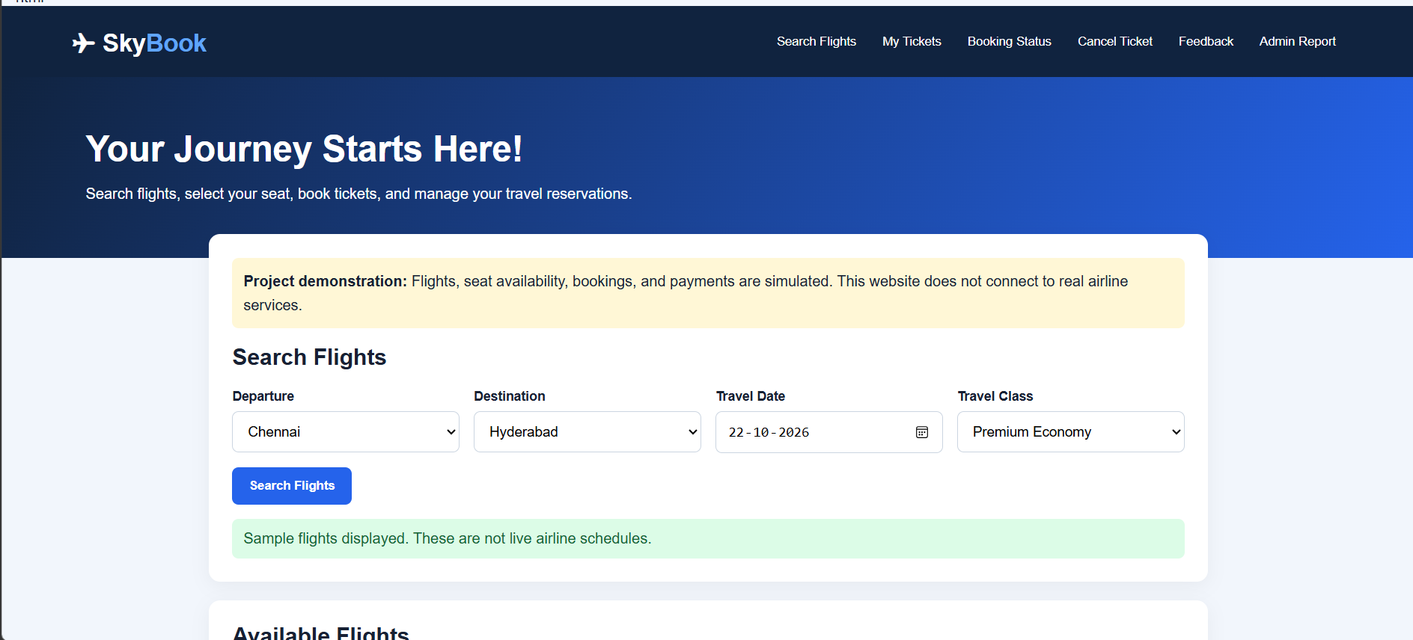
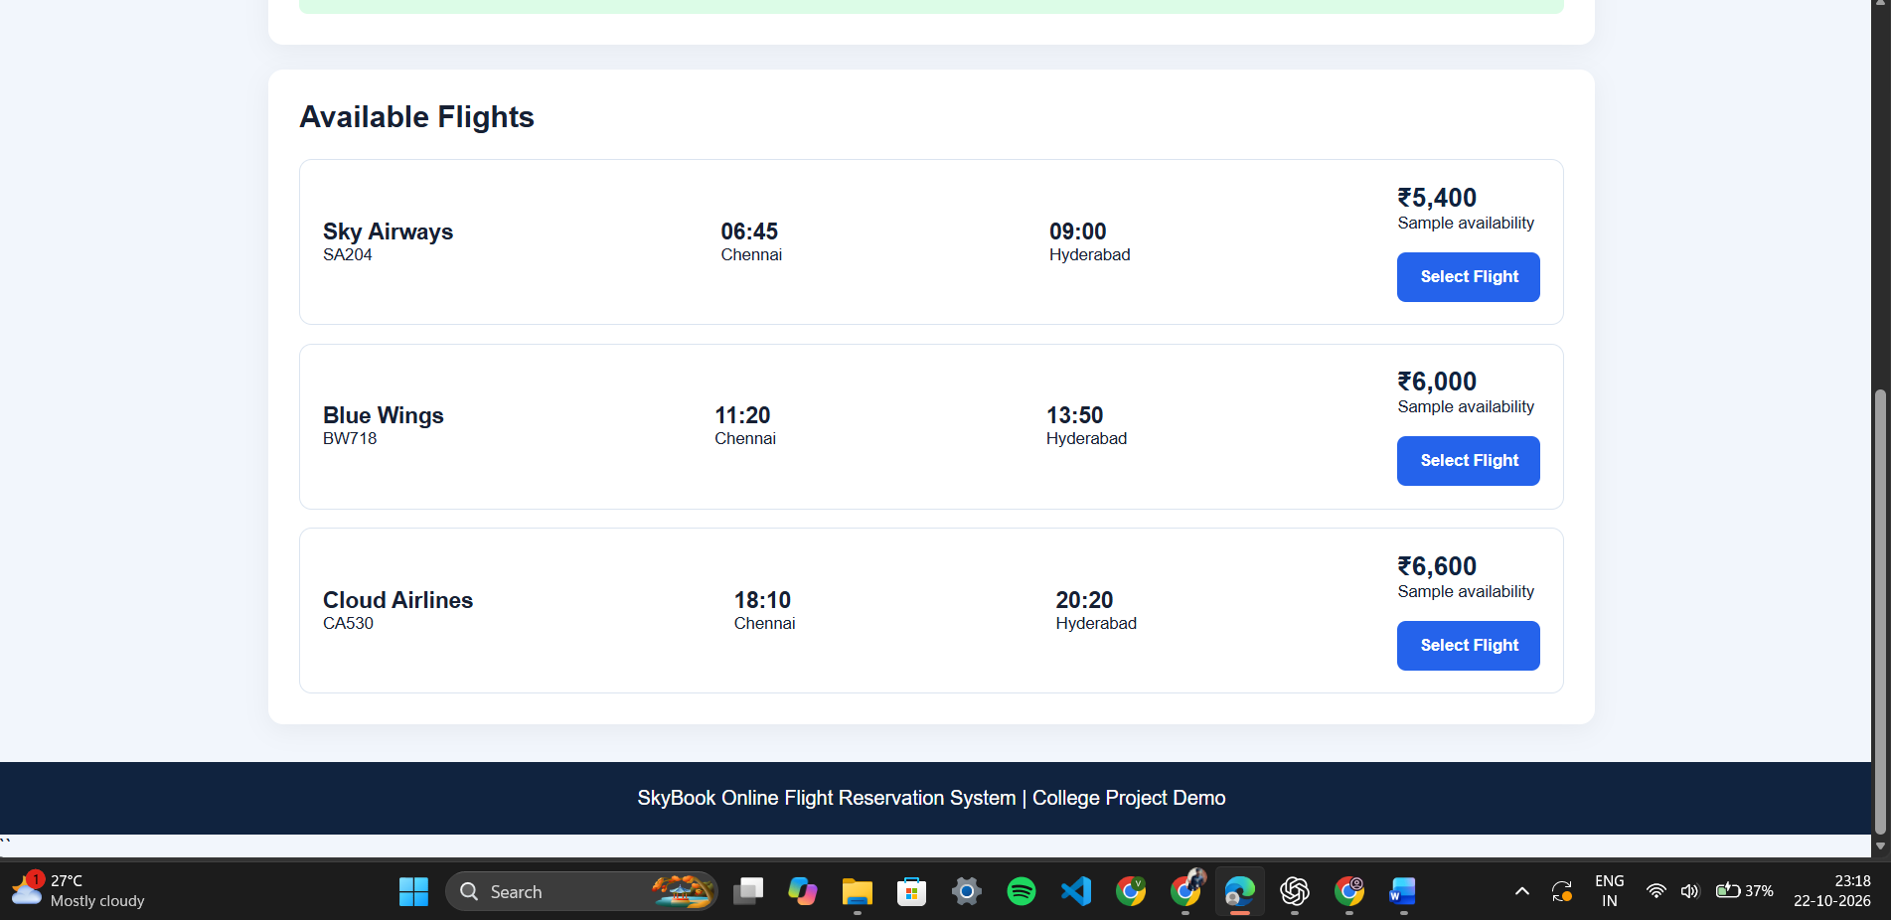
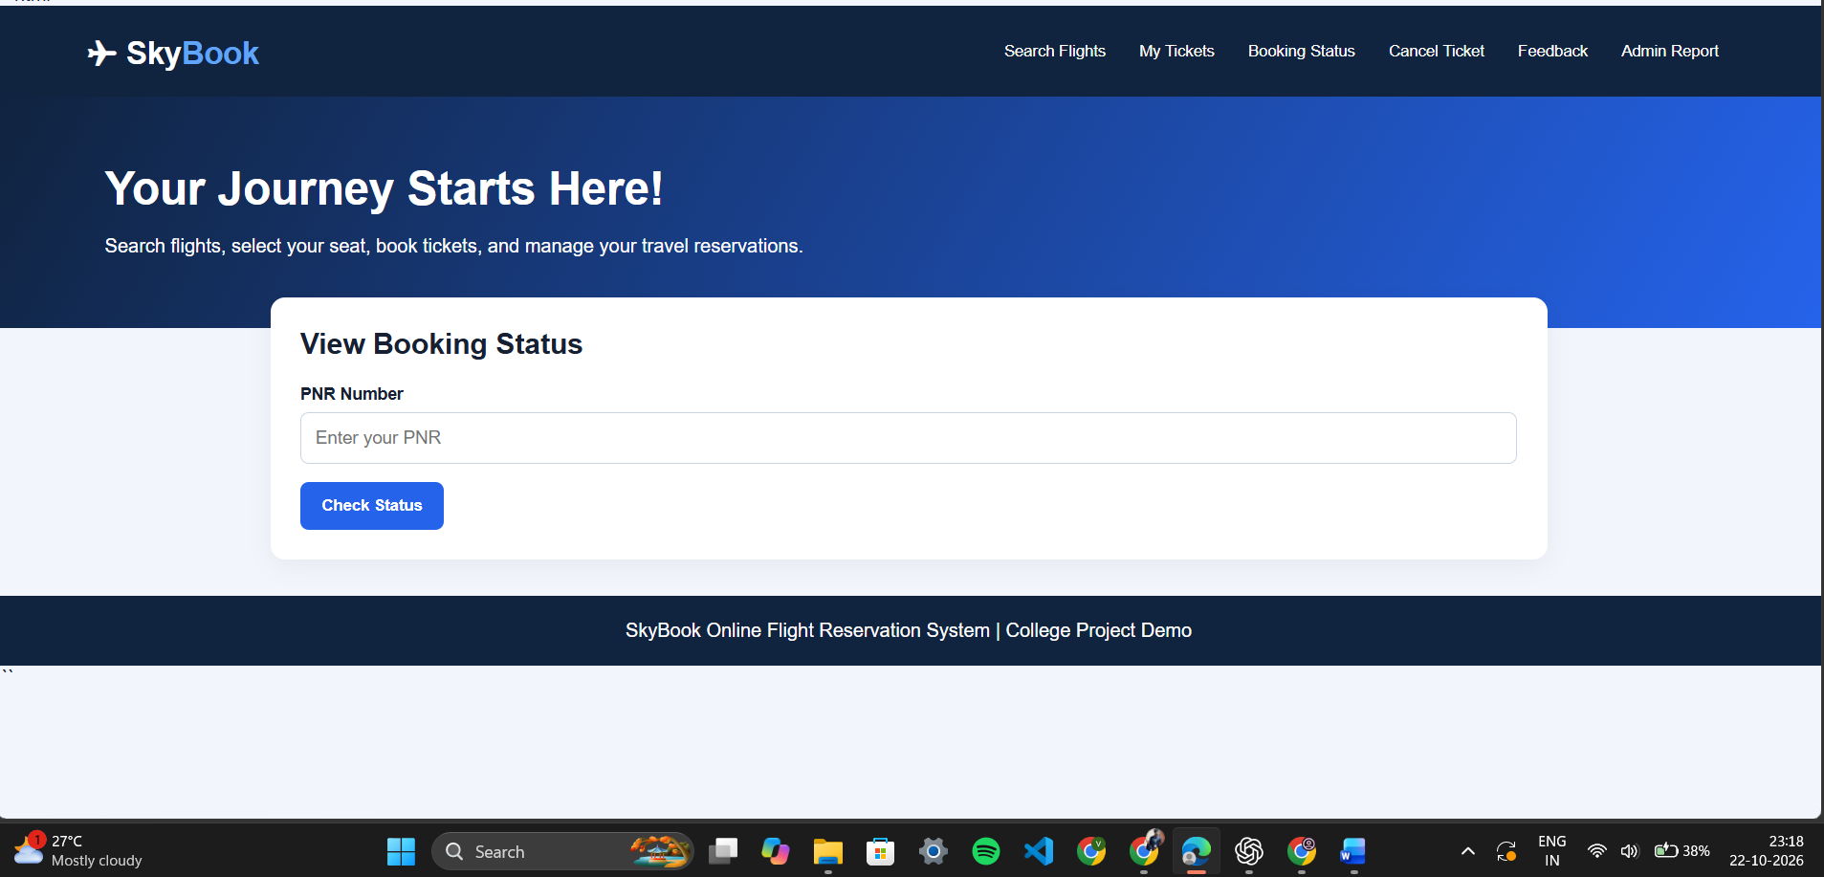

RESULT
Thus, the Online Flight Reservation System was successfully designed and implemented using HTML, CSS, and JavaScript. The system allows users to search flights, book tickets, check booking status, cancel reservations, view booking history, and print tickets through a user-friendly interface.

